A. Heather Pache
Email: ahpache@kubeokt.com Tel#: +1 760.987.9814, 4789A Guadalcanal St., Ft Irwin CA 92310
website: http://ahpache.kubeokt.com/

PERSONAL CHARACTERISTICS
Hair: blonde Eyes: green/blue Height: 5’9.5”
Weight: 160 Body type: curvy Size: 10
Portrayal ages on film: 40-50 Skin type: fair (Caucasian) with freckles
Portrayal ages on stage: 25-40

FILM
2014 Braziiiil! Heather Met Film School
2013 Killing All The Flies (TV series) Nurse Stuttgart Film Academy
2010 Iraq Dogs, (Film) Nurse Diana Smith Sommerfilm/Kontrastfilm
2009 The Family Channel commercial Mom of teenagers AFN (Armed Forces Network)

VOICEOVERS
2000 Computer game: Evil Islands,
Multiple characters KenRon Productions
Computer game: Mars Defense,
Major Berg

THEATER
**Award Winning
2014 Death
The Doctor (and multiple characters) NEAT (New English American Theater)
Dark Monday-Readers Theater
April: Paulette Goddard/Gloria McClean/Jutta Remarque
March: Nell-Rodeo Clowns
February: Edith-Let’s Go Already

2013 Dark Monday-Readers Theater NEAT (New English American Theater)
October: The Medicine and variety
Beauty & The Beast Stuttgart Theater Center
Townsperson/Enchanted plate
Hope & Mercy **
Marcia Hope
The Women**
Olga, plus multiple characters
Dracula
Van Helsing

2012 The Event** NEAT (New English American Theater)
Walter
Cinderella Stuttgart Theater Center
The Shy Girl

2011 Rumors Stuttgart Theater Center
Cookie
2010 A Midsummer Night’s Sleepover Wiesbaden American Middle School
Set designer/builder

A Little Murder Never Hurt Anybody** Amelia Earhart Playhouse
Café Manager
Your Mother’s Butt,
Psychologist

2009 Oggaline and The Time Machine Wiesbaden American Middle School
Assistant Director
Wing Nuts Improv. Theater Amelia Earhart Playhouse
“Wing Nut”
It’s a Wonderful Life
Multiple characters: Angel-Narrator/Mrs. Thompson/Nickie
Sonny DeRee’s Life Flashes Before His Eyes
Mick
2008 Something Wonderful Right Away Amelia Earhart Playhouse
Multiple characters
The Whole Shebang
Professor Alpha
2007 The BFG Romer Studios
Writer/Director
2000 Nuncrackers Roadside Theater
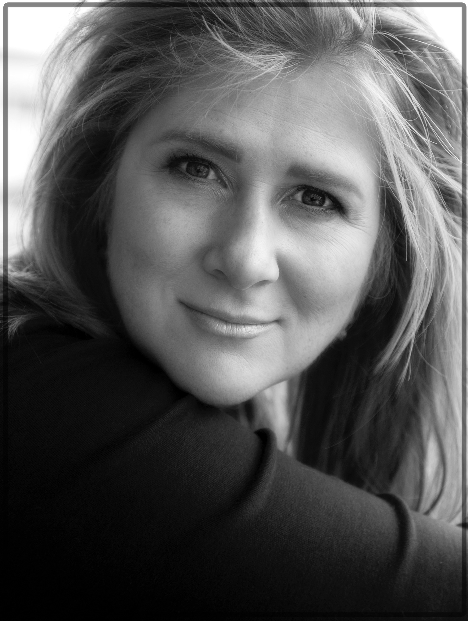
Rev. Mother Mary Regina

TRAINING
Tap dancing course with NEAT November 2013-May 2014
Acting for Film, Met Film School, London England July-August 2013
Audition Workshop, Stuttgart Theater Company Feb-2013
Character Development, Stuttgart Theater Company Feb-Apr. 2011
Improv. Workshops, Amelia Earhart Theater Feb-Apr. 2009

SPECIAL TALENTS: Character creations, Accents/dialects, Fitness Instructor, Cooking, Writing, Working with children

ACTING RESUME SUMMARY: Ann Heather Alexander is my birth name-I love my initials “AHA” because they scream a level of excitement that is indicative of my passion for discovery and creation. Since 2000, I have been involved in Community Theater on military posts in Germany as an actor, stage manager, set designer, script writer, director and assistant director. My interest lies in building a career in voiceovers and film.

